Richard Harrison, John Lamanuzzi, Eric Pires

Team 3

ECE 388

7 November, 2016

Climate Control and Room Occupancy System Requirements

**Consumer System Overview**

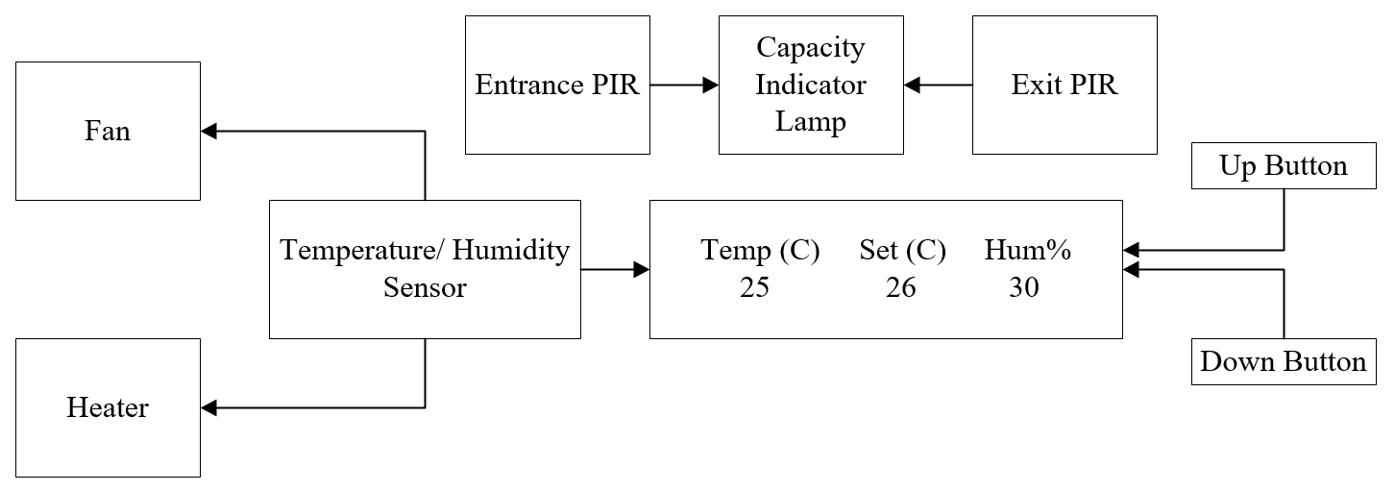

The Climate Control and Room Occupancy system will provide a temperature and humidity reading of the given enclosed environment. The temperature can be manipulated through the control panel buttons. When the user specifies a cooler temperature, the two case fans will activate and cool the environment. Similarly, when the user specifies a warmer temperature, the heater fan will activate and heat the environment. When the desired temperature is met, the respective fan will deactivate. The system will also provide a rough estimate of room occupancy. When the maximum amount of entities is detected through the entrance (5), the MAX led on the board will activate. This will emulate a warning signal that will emulate a security alert. The desk lamp will act as the lighting source of the environment. This source will activate when there are one or more entities present in the environment. It will turn off when all entities have left the environment.

The system will be modeled inside a 72 qt storage tote. The main board will be adhesively attached to the inside part of the lid, with cabling run around the tote’s interior edges. The heater and desk lamp will be placed on the bottom of the tote with holes for cable routing. There will also be cutouts for the button panel, case fans, entrance and exit. The button panel board will be adhesively mounted on the outside of the tote. The case fans will be drilled into the sides of the tote. The IR sensors will be mounted to the entrance and exit slots.

**Processing**

ATMega328p

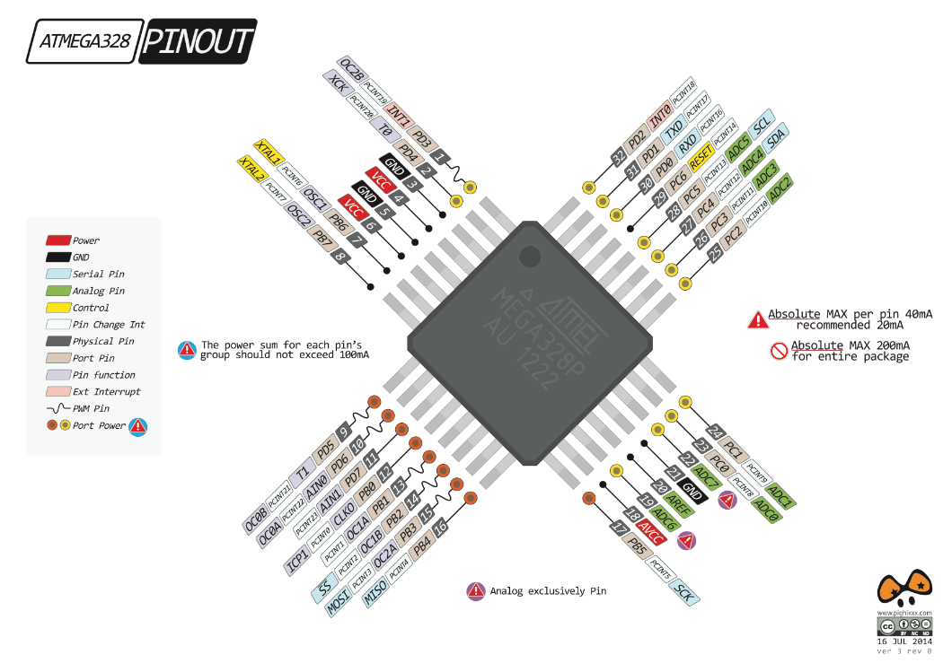The ATMega328p surface mount microcontroller will handle all interrupt and input processing on board for this system. The 328p has 23 I/O pins and 32KB of memory on chip, which is sufficient for the storage of all code and related libraries for the project. The 328p accepts an input voltage of 5V, and can provide voltage and max current of 200mA per pin. Accompanying the 328p is the HC-49/UP 16MHz crystal, as the system requires a timer for interrupt handling. The input and output pins for this system will be explained in their respective sections.

*Inputs/ Sensors:*

DHT22 Temperature and Humidity Sensor:

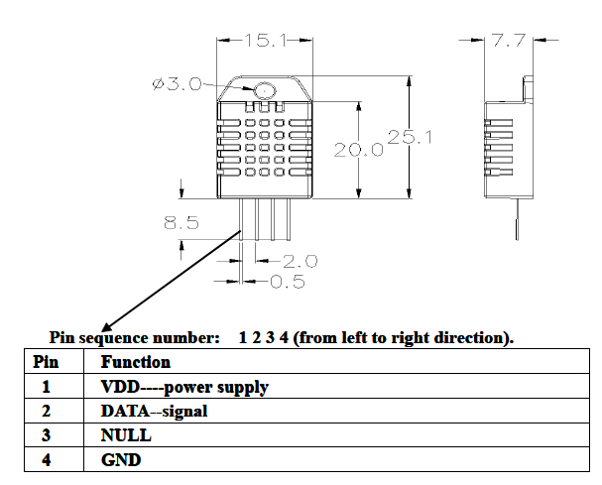 The DHT22 is a digital temperature and humidity sensor that will provide all relevant readings of the room climate for the project. It is a 4-pin through-hole sensor, with the following pinout and dimensions:

The device is 15.1*25.1*7.7mm with a digital pinout that contains connections for power, output, NULL, and ground. The operating range of voltage that the device requires is 3.3-6V. The sensor will use 5V and can takes a reading every two seconds. Interfacing with the device will be from pin #2 (signal) on the sensor to PD7 of the ATMega328p. The device only requires one digital pin to read temperature and humidity values. Processing for the signal input comes from the DHT22 library written for AVR microcontrollers. The default setting for temperature conversion is Celsius, which will be metric used for the system.

Infrared Obstacle Avoidance Sensor:

Two IR obstacle avoidance sensors are the chosen motion sensors for the project. These 3-pin sensors will be mounted at the entrance and exit of the room and serve as a room occupancy estimator. To simplify the process, one sensor will increase the room occupancy counter when triggered while the other decreases the count. They will be mounted to the modeled environment and connect to the corresponding board headers (PIR_IN and PIR_OUT). The sensors’ pinouts are 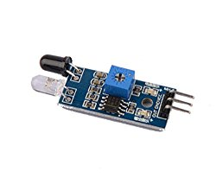as follows: pin 1 is Vcc (3.3-5V), pin 2 is ground, and pin 3 is OUT, which will be read by the ATMega328p through pins PC3 and PC4. These pins will be configured to trigger their respective interrupt vectors. The sensors feature LEDs on board that shine when an object is detected. The range of the sensor is 2-30cm with a conical detection angle of 35°. It utilizes a potentiometer for range adjustment and the board has dimensions of 31*15mm.

Tactile Button

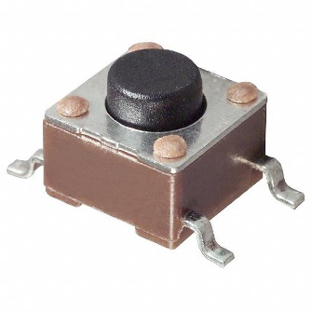 The project will utilize three SPST tactile switches. Two will serve as the interface between the user and the device. These will be the temperature control; one button will increment the temperature setting, and the other will decrement it. The third button will be interfaced directly with the RESET pin on the ATMega328p. The dimensions of the button are 11.2*5.9mm. The push buttons will be debounced though a RC pulldown network and an inverting schmitt trigger. These components will help filter noise and unwanted bouncing from the mechanical switching provided by the user.

**Outputs/ Actuators**

1602A Character LCD

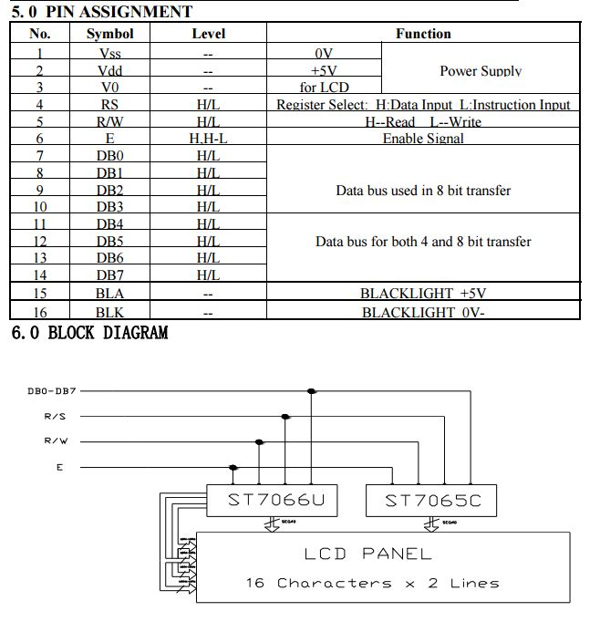 The 1602A LCD is responsible for displaying three values: the current temperature of the room, the humidity of the room, and the desired temperature setting. It is a 16-column, 2-line display with support for a variety of letters and symbols that are useful for this project and dimensions of 80*36*11mm. The LCD panel contains sixteen pins for connection to the microcontroller, although for this project only twelve are used. Both the crystal display and the backlight must be provided with power and ground signals, along with 6 I/O pins.

Honeywell HCE100R Heat Bud Ceramic Heater:

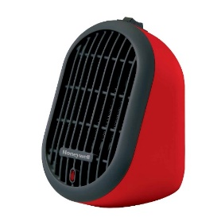 The Honeywell HCE100R will emulate the heating element for the system. It is a 170-250W heater that connects to a wall outlet, supplying a maximum of 2.27A. The dimensions of the heater are 105*144*165mm and requires the most power out of all components. Since the power requirements for the heater are much higher than the system can deliver, the heater will be switched through a relay that will trigger the device on with a logic level signal from PC1 of the microcontroller. The relay can handle up to 10A and 277 VAC.

12VDC Computer Case Fan

For cooling, the system will utilize two 12VDC, 250mA computer case fans to move air throughout the modeled environment. It will connect to the board using a JST and be switched using a MOSFET connected to 12VDC power cable from the board’s barrel jack. Pin PC2 will drive the gate terminal of the MOSFET and control the fans. A splitter cable will be used to attach both fans through one on-board connector.

40W Desk Lamp:

The desk lamp will emulate the lighting in the modeled environment. This lamp will trigger when the room contains at least one present entity. This light will be switched off when no entities are detected. This will be done in accordance with the IR sensor, which is responsible for keeping the count of entities present within the environment. Once again, this lamp’s power requirement is far too large to be powered by the microcontroller (40W, 363 mA). Therefore another relay will be used to control the light source through PC0 of the microcontroller. This relay will be the same as described for the heater.

**System Flow Diagram**

